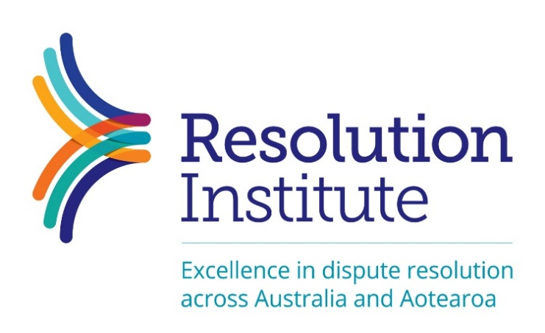
Nomination for Resolution Institute Certificate Award for: Achievement by an emerging practitioner

Nominating someone for a Resolution Institute Award
Receiving a Resolution Institute Award is recognition that the nominated practitioner has gone “above and beyond” in their particular area or category of dispute resolution practice and/or dispute management work. The Awards are to acknowledge outstanding practice and are based on more than a person’s day-to-day work, however admirable that may be.
Nominations are made by peers and other practitioners who have seen or have knowledge of the nominees’ outstanding dispute resolution practice and/or dispute management work.
Each nominee must be individually nominated by two people. Each nominator must separately submit their own reasons why the practitioner is being nominated, with evidence and/or examples to support the nomination. A nominator cannot just endorse the comments of another nominator: it is therefore recommended that, as far as is possible, each nominator provides separate and distinct reflections about the nominee.
The Awards and Acknowledgment Committee assesses each nomination based only on the information provided in the nomination form. As such, it is vital that each nominator provides sufficient information about the nominee’s practice to show they are worthy of this high honour. The Award details below provide examples of what information may be relevant and necessary. Awards will only be made conferred where there is clear evidence of the award conditions being satisfied.
Once the Awards and Acknowledgment Committee assesses the nominations, the Committee recommends to the Resolution Institute Board the names of those who have fulfilled the criteria to receive the Award they were nominated for.
Certificate Award for achievement by an emerging practitioner
This award can be awarded to a dispute resolution practitioner in any dispute resolution context.
We are seeking to award and recognise Resolution Institute members who are early in their dispute resolution and/or dispute management work and already achieving great outcomes in some form. For example, they could be building practice and have excellent feedback from participants on their support, skill and/or competencies demonstrated in a distinct dispute resolution area of practice. The practitioner should be in their first or second year of providing dispute resolution services. The area of practice and the time the nominee has been in that area must be clearly defined as part of the nomination process.
A nomination requires two nominators, each providing detail of the nominee’s achievement.

Nominee
Full name:
Contact Details: Phone:
E-mail:
Nominee – current membership status
For office to supply

Define the area of practice
Nominated by:
Full name:
Organisation:
Contact Details: Phone:
E-mail:

Detail of the nominee’s achievement
(please provide as much detail as possible to assist the Acknowledgements and Awards Committee in their recommendation, you may be contacted for further information. Please include where/how you encountered the nominee’s practice. You are welcome to send this as an attachment if preferred).
Nominated by:
Full name:
Organisation:
Contact Details:
Phone:
E-mail:
Detail of the nominee’s achievement
(please provide as much detail as possible to assist the Acknowledgements and Awards Committee in their recommendation, you may be contacted for further information. Please include where/how you encountered the nominee’s practice. You are welcome to send this as an attachment if preferred).

This may include, but is not limited to, Indigenous peacemaking, Aboriginal and Torres Strait Islander training and practice in remote areas, developing Maori and Pasifika practice, restorative justice, restorative practice, facilitative processes, evaluative processes, determinative processes, conciliation, peer mediation in schools, family mediation approaches from a variety of different frameworks, publishing, organising special DR events, researching, presenting webinars, masterclasses, outreach and online practice to bring services to the outback, and overall leadership in dispute resolution management.

